# Event ID 3760 error in the Event Log on all the WFE server

## Problem

SQL Database 'SPSPRD_MySpace' on SQL Server instance 'AG-SPSPRD-CFG.awp.nhs.uk' not found. Additional error information from SQL Server is included below.

Cannot open database "SPSPRD_MySpace" requested by the login. The login failed.

Login failed for user 'AWWT\SPP_WebAppPool'.

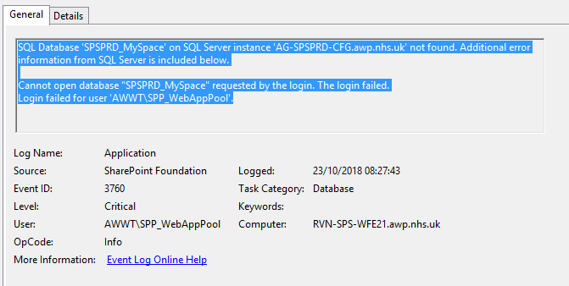

## Analysis

The user SPP_WebAppPool does not exist in the SPSPRD_MySpace database.

Why does this account require access anyway?

My Space web site was showing as stopped in IIS Manager on WFE21 and WFE22. I started the site on 26/10/2018 at 11:40. No repeat of the 3760 errors in the database so far today.

Comparisons of App Pool accounts used by UAT and PROD are very confusing!

## Update – 30/10/2018

No repeat of errors since 26/10/2018

## SQL Login Details

Here is the list of databases where the login is associated with a database user:

